

**EH2745 Computer Applications in Power Systems**

**Assignment 2**

**Group 6:**

**Abeer Mrad**

**Siyu Zhang**

The main purpose of assignment 2 is to analyse a dataset of 9 bus system which is extracted from CIM XML. The data base of the provided power system represents a group of different operational states, the states of the power system is presented below:

* High load rate during peak hours
* Shut down of generator for maintenance
* Low load rate during night
* Disconnection of a line for maintenance

The main part of the assignment is to use the skills of Java programming and machine learning to solve the following requirements:

* Developing K-mean algorithm to identify the different operational states in the database, chose a proper label for the states and link the different clusters to different states.
* Develop K-nearest neighbours algorithm to identify the unknown, previous mentioned states based on the voltage measurement.

In order to solve the assignment, the database of the given 9 bus system is used. This data base contains 200 points that have to be clustered in 4 states. First, the k- initial centroids of the clusters is defined randomly from the dataset. The next step is to calculate the distances between the states and each centre, in order to assign the state to the nearest centre based on the shortest distance, then recalculate the position of the centres again and keep the same procedure until the there is no difference in the centroids.

The result of that is the 200 points given in the database have been grouped in four different groups i.e. four different clusters, depending on the previous chosen centroids.

The number of points of each cluster presented below:

1. 49

2. 47

3. 53

4. 51

The average voltage and angle of each point is shown in Figure 1.

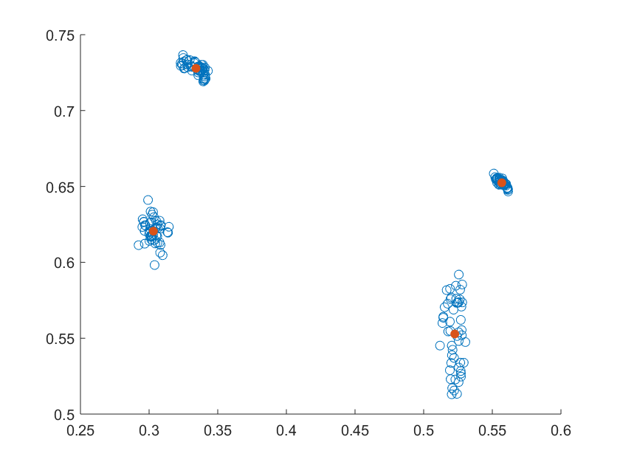

4

2

1

3

Figure 1 Plot of points

Centroids of each cluster is shown in Table 1.

Table 1 Centroids of each cluster

|  |  |  |  |  |  |  |  |  |
| --- | --- | --- | --- | --- | --- | --- | --- | --- |
| Bus | Cluster 1  Voltage | Cluster 1  Angle | Cluster 2  Voltage | Cluster 2  Angle | Cluster 3  Voltage | Cluster 3  Angle | Cluster 4  Voltage | Cluster 4  Angle |
| 1  Clark | 1 | 0° | 1 | 0° | 1 | 0° | 1 | 0° |
| 2 Amherst | 1 | -20.76° | 1 | 18.54° | 1 | 1.83° | 1 | 24.61° |
| 3 Winlock | 1 | -25.10° | 1 | 19.68° | 1 | -9.24° | 1 | 19.36° |
| 4 Bowman | 0.90 | -15.22° | 0.97 | -2.70° | 0.99 | -5.29° | 0.99 | 4.22° |
| 5  Troy | 0.85 | -27.52° | 0.94 | -7.83° | 0.98 | -9.83° | 0.99 | 7.46° |
| 6  Maple | 0.95 | -28.10° | 1.01 | 16.84° | 1 | -9.24° | 1.01 | 16.54° |
| 7  Grand | 0.90 | -32.91° | 0.98 | 11.99° | 0.98 | -8.62° | 1.01 | 17.04° |
| 8 Wautaga | 0.94 | -26.99° | 0.99 | 12.63° | 1 | -4.04° | 1.01 | 18.82° |
| 9  Cross | 0.81 | -29.86° | 0.93 | -1.74° | 0.96 | -8.97° | 0.98 | 7.72° |

Then next step is to allocate the cluster to the state.

Bus 5, 7 and 9 are connected to the load bus. The voltage of load bus in cluster 1 is lower than the rest. Thus cluster 1 belongs to High Load state.

Similarly, the voltage of load bus in cluster 4 is higher than the rest. Thus cluster 4 belongs to High Load state.

Bus 3 is connected to the generator. All the active power flows through the line between 3 and 6. The active power flows from higher angle to lower angle. We can see there is dynamic angle decrease in cluster 1, 2 and 4. For cluster 3, the angle of bus 3 is same of it of bus 6, which means no active power flow. Thus, cluster 3 belongs to Shut down of generator.

The voltage drop between bus 5 and 6 can show the state of line connection. We assume the difference is only dependent on PR + QX. When the power is same, the increase of impedance brings in higher voltage drop. The state of line connection influences the impedance. Disconnected line means the active power needs to go a long way with larger impedance. For cluster 2, it has higher voltage drop. Thus, cluster 2 belongs to Disconnection of a line.